**Ayesha Zubair**

**52916**

**Lab 10**

**Task**

START:

INP

STA NUM

LDA NUM

OUT

HALT

NUM: .data 1 0

**Output:**

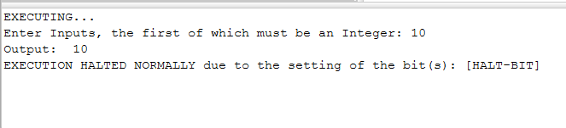

In this task, 10 was entered which remained the same on output which is documented above.